

**Introduction to DBMS**

**Dr. Amit Vajpayee**

Department of Computer Science and Engineering,

Chitkara University, Punjab



**Introduction**

* Purpose of Database Systems
* View of Data
* Data Models
* Data Definition Language
* Data Manipulation Language
* Transaction Management
* Storage Management
* Database Administrator
* Database Users
* Overall System Structure



**Database Management System (DBMS)**

* **Collection of interrelated data**
* **Set of programs to access the data**
* **DBMS contains information about a particular enterprise**
* **DBMS provides an environment that is both *convenient* and**

***efficient* to use.**

* **Database Applications:**
  + Banking: all transactions
  + Airlines: reservations, schedules
  + Universities: registration, grades
  + Sales: customers, products, purchases
  + Manufacturing: production, inventory, orders, supply chain
  + Human resources: employee records, salaries, tax

deductions

* Databases touch all aspects of our lives



**Purpose of Database System**

* In the early days, database applications were built on top of

file systems

* Drawbacks of using file systems to store data:
  + **Data redundancy and inconsistency**
    - Multiple file formats, duplication of information in different files
  + **Difficulty in accessing data**
    - Need to write a new program to carry out each new task
  + **Data isolation** — multiple files and formats
  + **Integrity problems**
    - Integrity constraints (e.g. account balance > 0) become part of

program code

* + - Hard to add new constraints or change existing ones



Purpose of Database Systems (Cont.)

* Drawbacks of using file systems (cont.)
  + **Atomicity of updates**
    - Failures may leave database in an inconsistent state with partial

updates carried out

* + - E.g. transfer of funds from one account to another should either

complete or not happen at all

* + **Concurrent access by multiple users**
    - Concurrent accessed needed for performance
    - Uncontrolled concurrent accesses can lead to inconsistencies
      * E.g. two people reading a balance and updating it at the same

time

* + **Security problems**
* Database systems offer solutions to all the above problems



Levels of Abstraction

* **Physical level** :describes how a record (e.g., customer) is

stored.

* **Logical level:** describes data stored in database, and the

relationships among the data.

**type** customer = **record**

*name* : string; *street* : string; *city* : integer;

**end**;

* **View level:** application programs hide details of data types. Views can also hide information (e.g., salary) for security purposes.



View of Data

* An architecture for a database system

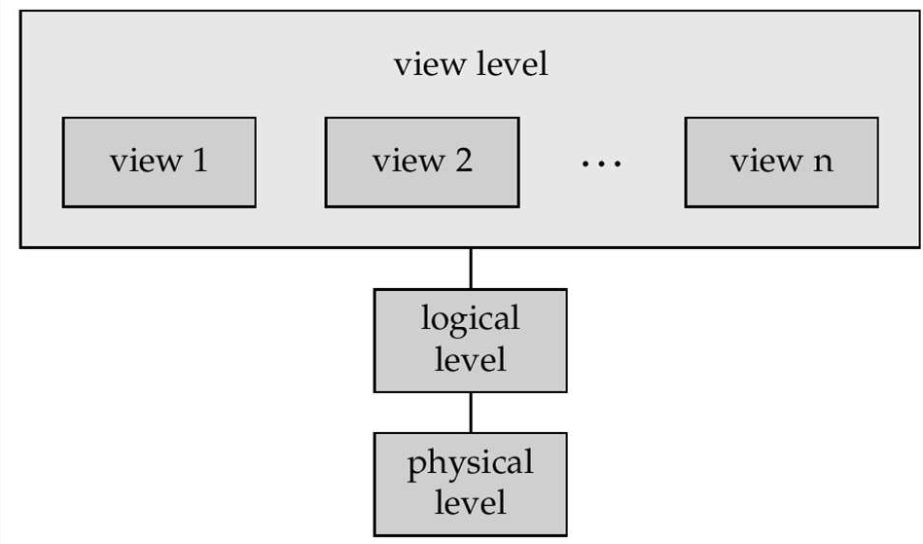

**Instances and Schemas**

* Similar to types and variables in programming languages
* **Schema** – the logical structure of the database
  + e.g., the database consists of information about a set of customers

and accounts and the relationship between them)

* + Analogous to type information of a variable in a program
  + **Physical schema**: database design at the physical level
  + **Logical schema**: database design at the logical level
* **Instance** – the actual content of the database at a particular point in time
  + Analogous to the value of a variable



**Data Independence**

* **Data Independence :** The ability to modify the one

schema without changing the other schema.

* Data Independence have two types-

1. Physical Data Independence
2. Logical Data Independence

* **Physical Data Independence :** The ability to modify the physical schema without changing the logical schema
* **Logical Data Independence :** The ability to modify the logical schema without changing the physical schema



**Data Definition Language (DDL)**

* Specification notation for defining the database schema
  + E.g.

**create table** *account* ( *account-number* **char**(10), *balance* **integer**)

* DDL compiler generates a set of tables stored in a *data dictionary*
* Data dictionary contains metadata (i.e., data about data) database schema
  + Data *storage and definition* language
    - language in which the storage structure and access

methods used by the database system are specified

* + - Usually an extension of the data definition language



**Data**

**Manipulation**

**Language**

**(DML)**

* Language for accessing and manipulating the data

organized by the appropriate data model

* + DML also known as query language
* Two classes of languages
  + Procedural – user specifies what data is required and how to get those data
  + Nonprocedural – user specifies what data is required without specifying how to get those data
* SQL is the most widely used query language



SQL

* SQL: widely used non-procedural language
  + E.g. find the name of the customer with customer-id 192-83-7465

**select** *customer.customer-name*

**from** *customer*

**where** *customer.customer-id* = ‘192-83-7465’

* + E.g. find the balances of all accounts held by the customer with customer-id 192-83-7465

**select** *account.balance*

**from** *depositor*, *account*

**where** *depositor.customer-id* = ‘192-83-7465’ **and**

*depositor.account-number = account.account-number*

* Application programs generally access databases through one of
  + Language extensions to allow embedded SQL
  + Application program interface (e.g. ODBC/JDBC) which allow SQL queries to be sent to a

database



**Database Users**

Users are differentiated by the way they expect to interact with the

system

* **Application programmers** – interact with system through DML calls
* **Sophisticated users** – form requests in a database query language
* **Specialized users** – write specialized database applications that do

not fit into the traditional data processing framework

* **Naïve users** – invoke one of the permanent application programs

that have been written previously

* + E.g. people accessing database over the web, bank tellers,

clerical staff



Database Administrator

* Coordinates all the activities of the database system; the database administrator has a good understanding of the enterprise’s information resources and needs.
* Database administrator's duties include:

✔ Schema definition

✔ Storage structure and access method definition

✔ Schema and physical organization modification

✔ Granting user authority to access the database

✔ Specifying integrity constraints

✔ Acting as liaison with users

✔ Monitoring performance and responding to changes in requirements



Transaction Management

* + A *transaction* is a collection of operations that performs a

single logical function in a database application

* + Transaction-management component ensures that the database remains in a consistent (correct) state despite system failures (e.g., power failures and operating system crashes) and transaction failures.
  + Concurrency-control manager controls the interaction among the concurrent transactions, to ensure the consistency of the database.



Storage Management

* + Storage manager is a program module that provides the interface between the low-level data stored in the database and the application programs and queries submitted to the system.
  + The storage manager is responsible to the following

tasks:

* + - interaction with the file manager
    - efficient storing, retrieving and updating of data

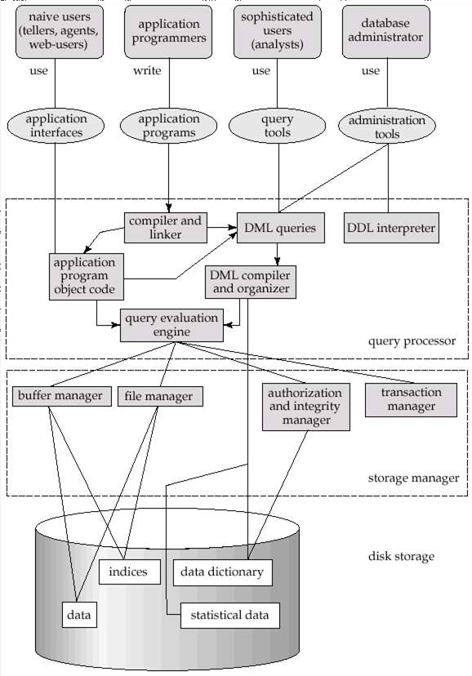

1



Application Architectures

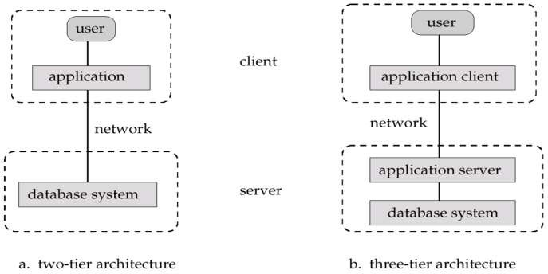

* **Two-tier architecture**: E.g. client programs using ODBC/JDBC to

communicate with a database

* **Three-tier architecture**: E.g. web-based applications, and

applications built using “middleware”

1





Computer Networks Dr. Vidhu Baggan